INTRODUCTION

Cybersecurity in Wireless Sensor Networks
Wireless Sensor Networks (WSNs) are widely used in modern technological applications such as environmental monitoring, industrial automation, healthcare systems, and smart infrastructure. These networks consist of multiple sensor nodes that collect and transmit data wirelessly to a central base station. Due to their distributed architecture and wireless communication nature, WSNs play a critical role in enabling real-time data acquisition and intelligent decision-making.

However, the open communication medium and limited hardware resources of WSNs make them highly vulnerable to cyberattacks. Unlike traditional networks, sensor nodes in WSNs have constrained processing power, memory, and battery life, which limits the implementation of complex security mechanisms. As a result, attackers can easily exploit these vulnerabilities to disrupt network operations, manipulate data, or degrade system performance.

Cybersecurity in WSNs focuses on protecting network communication, ensuring data integrity, and preventing unauthorized access or malicious activities. In such networks, maintaining secure communication is essential because any compromise can lead to incorrect data interpretation, system malfunction, or even complete network failure.

Various types of cyberattacks target WSNs due to their weak security infrastructure. Among the most common attacks are Blackhole attacks, Grayhole attacks, Flooding attacks, and Time Division Multiple Access (TDMA)-based attacks. These attacks exploit routing protocols, communication patterns, and node behavior to disrupt the network.

In a Blackhole attack, a malicious node falsely advertises itself as having the best route to the base station and then drops all incoming data packets. In a Grayhole attack, the malicious node selectively drops packets, making detection more difficult. Flooding attacks generate excessive network traffic, consuming bandwidth and energy resources. TDMA-based attacks interfere with scheduled communication slots, causing collisions and network instability.

These threats highlight the importance of developing robust cybersecurity solutions specifically tailored for Wireless Sensor Networks.

Cyberattack Detection using Machine Learning
Traditional security techniques such as encryption and authentication are primarily used to protect data confidentiality and prevent unauthorized access. However, these methods are not sufficient to detect or classify cyberattacks occurring within the network.

To address this limitation, machine learning and deep learning techniques have been widely adopted in cybersecurity. These techniques analyze network traffic patterns and identify anomalies that indicate malicious activity. By learning from historical data, machine learning models can distinguish between normal and abnormal network behavior.

Several machine learning models such as Random Forest and XGBoost have been successfully used for cyberattack detection. These models provide high accuracy in classification tasks and can handle large datasets effectively. Deep learning models such as Multilayer Perceptron (MLP) further enhance detection capabilities by capturing complex nonlinear relationships in network data. In addition to supervised learning methods, unsupervised learning techniques such as Autoencoders are used for anomaly detection. These models learn the normal behavior of the network and identify deviations that may indicate unknown or emerging attacks.

However, relying on a single model for cyberattack detection has several limitations. Different models perform differently depending on the type of attack and network conditions. Some models may perform well for certain attack types but fail for others. Additionally, single-model approaches may lack stability and robustness in dynamic environments.

To overcome these challenges, the concept of ensemble learning is introduced. Ensemble learning combines multiple models to improve overall performance. By integrating different models, the system can leverage their individual strengths and reduce weaknesses.

Objectives
The objective of this system is to is to develop an efficient and intelligent cyberattack detection and classification system for Wireless Sensor Networks using a unified ensemble learning approach. The system is designed to integrate multiple machine learning and deep learning models, including Random Forest, XGBoost, Multilayer Perceptron (MLP), and Autoencoder, to enhance detection performance. It aims to accurately detect and classify various types of cyberattacks such as Blackhole, Grayhole, Flooding, and TDMA-based attacks while also identifying unknown or emerging threats through anomaly detection techniques. Additionally, the project focuses on improving detection accuracy, classification stability, and overall system reliability. The proposed system supports real-time monitoring and analysis of network traffic and provides forensic logging along with actionable recommendations to help prevent future cyberattacks.

Problem Statement
Wireless Sensor Networks (WSNs) are highly vulnerable to cyberattacks due to their limited resources and open wireless communication. Existing intrusion detection systems often rely on single models, which cannot accurately classify multiple attack types or detect unknown threats. They also struggle to adapt to dynamic network conditions and lack real-time monitoring capabilities. Therefore, there is a need for an efficient system that can accurately detect and classify various cyberattacks, identify new threats, and provide reliable performance, which is achieved using the proposed unified ensemble learning approach.

LITERATURE SURVEY
[1]. This paper presents a machine learning-based approach for detecting cyberattacks in Wireless Sensor Networks. The study focuses on identifying abnormal network behavior using classification algorithms and highlights the effectiveness of machine learning techniques in improving detection accuracy. However, the system primarily focuses on detection and does not provide detailed classification of multiple attack types.

[2]. This study proposes a predictive cybersecurity framework using machine learning and deep learning techniques for intrusion detection in WSN environments. The system improves detection performance by analyzing network traffic patterns, but it lacks adaptability to dynamic network conditions and does not effectively handle unknown or emerging attacks.

[3]. This paper explores intrusion detection in IoT and WSN environments using machine learning algorithms. The model analyzes network traffic to identify malicious activities and improve system security. Although the approach enhances detection capability, it does not provide consistent performance across different attack types.

[4]. This research provides a detailed analysis of the integration of machine learning techniques in Wireless Sensor Network security. The study highlights how different algorithms can improve attack detection and classification. However, it also emphasizes the challenges related to computational complexity and scalability in real-time environments.

[5]. This paper investigates machine learning-based detection of network security incidents in Wireless Sensor Networks. The system demonstrates good performance in identifying attacks but shows limitations in adapting to varying network conditions and evolving attack patterns.

[6]. This study proposes a hybrid feature reduction technique combined with machine learning for cyberattack detection. The approach improves detection efficiency by reducing redundant data features. However, it does not incorporate advanced ensemble techniques for improving classification stability.

[7]. This research focuses on enhancing WSN security using machine learning-based DoS attack detection. The system effectively detects denial-of-service attacks but is limited to specific attack types and lacks a generalized multi-attack detection framework.

[8]. This paper presents a machine learning and deep learning-based intrusion detection system for cybersecurity applications. The approach improves detection accuracy using advanced models but requires high computational resources, making it less suitable for resource-constrained WSN environments.

[9]. This study introduces a machine learning-based intrusion detection system for Wireless Sensor Networks that analyzes network behavior to identify malicious activity. While the system improves detection accuracy, it does not effectively classify multiple attack categories.

[10]. This research focuses on detecting network security incidents using machine learning models and highlights the importance of analyzing traffic patterns for identifying attacks. However, the system lacks integration of multiple models to enhance performance.

DESIGN

Existing System
In Wireless Sensor Networks, existing cyberattack detection systems mainly rely on traditional machine learning or deep learning models to identify malicious activities. These systems typically analyze network traffic data and classify it as normal or attack based on learned patterns. Common approaches include the use of algorithms such as Random Forest, XGBoost, Support Vector Machines, and neural networks.
Most of the existing systems focus only on detecting whether an attack is present in the network, without accurately classifying the type of attack. This limitation reduces the effectiveness of the system in real-world applications where identifying the exact attack type is crucial for implementing appropriate countermeasures.
Additionally, many systems rely on a single machine learning model, which leads to inconsistent performance across different types of attacks. Some models may perform well for specific attack types but fail to generalize across all scenarios. Furthermore, deep learning-based systems require high computational resources and are not suitable for resource-constrained environments like Wireless Sensor Networks.
Another major limitation of existing systems is their inability to detect unknown or emerging cyberattacks. Most systems are trained only on known attack patterns and fail to identify new threats that do not match the training data. Moreover, many systems lack real-time monitoring capabilities and do not provide detailed analysis or recommendations for preventing future attacks.

Disadvantages of Existing System
- Limited Attack Classification: Most existing systems are designed only to detect whether an attack is present or not, but they do not accurately classify different types of attacks such as Blackhole, Grayhole, Flooding, and TDMA. This limitation reduces the effectiveness of the system in real-world scenarios where identifying the type of attack is essential for applying proper countermeasures.
- Dependence on Single Model: Many existing intrusion detection systems rely on a single machine learning or deep learning model. As a result, the system performance becomes inconsistent because different models perform differently for various attack types. This lack of model diversity reduces the overall reliability and robustness of the system.
- Inability to Detect Unknown Attacks: Most systems are trained using predefined datasets containing known attack patterns. These systems fail to detect new or emerging cyber threats that do not match the training data, making them ineffective against evolving attack strategies.
- Lack of Adaptability: Existing systems are not capable of adapting to dynamic network conditions. Changes in network traffic patterns, node behavior, or attack strategies can significantly affect system performance, leading to inaccurate results.
- No Real-Time Monitoring: Many existing approaches do not support real-time monitoring and analysis of network traffic. This delay in detection reduces the system’s ability to respond quickly to cyberattacks.

Proposed System
To overcome the limitations of existing systems, this project proposes a Unified Stacking Ensemble Learning Framework for cyberattack detection and classification in Wireless Sensor Networks.
The proposed system integrates multiple machine learning and deep learning models, including Random Forest, XGBoost, Multilayer Perceptron (MLP), and Autoencoder, into a single unified framework. This combination allows the system to leverage the strengths of each model and improve overall detection accuracy and reliability.
The system uses supervised learning techniques to classify known cyberattacks and unsupervised learning techniques to detect unknown or emerging threats. Random Forest and XGBoost models are used for robust classification of known attacks, while the MLP model captures complex nonlinear relationships in network data. The Autoencoder is used for anomaly detection by identifying deviations from normal network behavior.
The proposed system is trained using the WSN-DS dataset, which contains various types of network traffic data, including normal and malicious activities. Additionally, the system is evaluated using network traffic generated from the COOJA simulation environment to ensure realistic testing conditions.
The use of stacking ensemble learning enables the system to combine the outputs of individual models and produce a final prediction with improved accuracy and stability. This approach enhances the system’s ability to detect complex attack patterns and adapt to dynamic network environments.

System Architecture
The system architecture of the proposed unified ensemble learning framework is designed to efficiently detect and classify cyberattacks in WSNs. The architecture provides a structured approach for processing network data, applying machine learning models, and generating accurate detection results. It ensures smooth interaction between different components of the system and supports real-time monitoring and analysis of cyber threats.
The proposed system architecture mainly consists of three major modules: the User Interface module, the Cyberattack Detection Engine, and the Data Storage module. These modules work together to perform data processing, attack detection, classification, and result storage in an organized manner.
Initially, the system receives input data from two main sources: the WSN-DS dataset and the network traffic generated using the COOJA simulation environment. These datasets include both normal and malicious network behavior, which are essential for training and evaluating the detection models.
Once the data is collected, it is passed to the preprocessing stage, where several operations such as data cleaning, normalization, and feature selection are performed. Data cleaning removes unnecessary or inconsistent values, normalization scales the data for better model performance, and feature selection identifies the most relevant attributes for analysis. These preprocessing steps improve the quality of data and enhance the accuracy of the models.
After preprocessing, the data is analyzed using multiple machine learning and deep learning models, including Random Forest, XGBoost, and Multilayer Perceptron (MLP). Each model processes the data independently and generates predictions based on learned patterns. These outputs are combined using a stacking ensemble learning approach to produce a final classification result with improved accuracy and stability.
In addition, an Autoencoder model is used for anomaly detection to identify unknown or emerging cyberattacks by detecting deviations from normal network behavior. The final output includes attack detection, classification of attack types, and analysis results, which are stored for future reference and security monitoring.
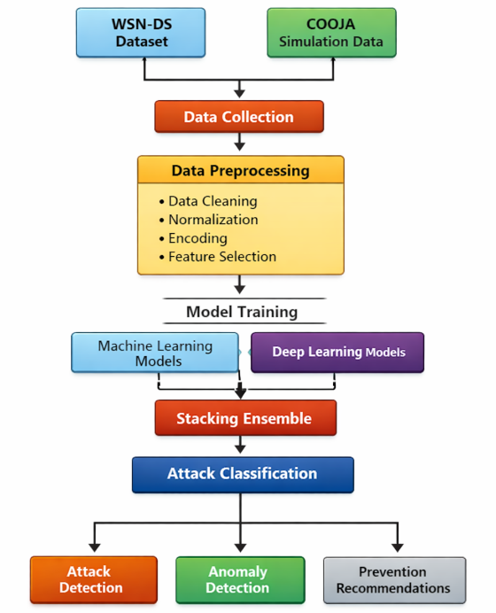

Fig 3.2.1 : System Architecture

System Modules
The proposed system is divided into several modules to ensure efficient processing, accurate detection, and proper management of cyberattack data in Wireless Sensor Networks. Each module performs a specific function and collectively contributes to the overall working of the system.

User Interface Module
The User Interface module provides interaction between the user and the system. It allows users to upload datasets, initiate the cyberattack detection process, and view the results generated by the system. This module also supports user authentication to ensure secure access. Additionally, users can access information such as detected attack types, anomaly alerts, and prevention recommendations through this interface.

Cyberattack Detection Engine
The Cyberattack Detection Engine is the core component of the system, responsible for processing data and detecting cyberattacks. It performs preprocessing steps such as data cleaning, normalization, encoding, and feature selection to improve data quality. After preprocessing, it applies machine learning models like Random Forest and XGBoost, along with deep learning models such as Multilayer Perceptron, to analyze network traffic.
The outputs from these models are combined using stacking ensemble learning to produce accurate classification results. Additionally, an Autoencoder is used for anomaly detection to identify unknown or emerging cyberattacks. This module ensures reliable and efficient detection of both known and unknown threats.

Data Storage Module
The Data Storage module is responsible for storing all relevant data, including input datasets, processed data, detection results, and forensic logs. It maintains records of detected attacks, classification results, and system performance metrics. These stored logs help in analyzing past incidents and support long-term monitoring of network security. The module also enables easy retrieval of data for further analysis and reporting.
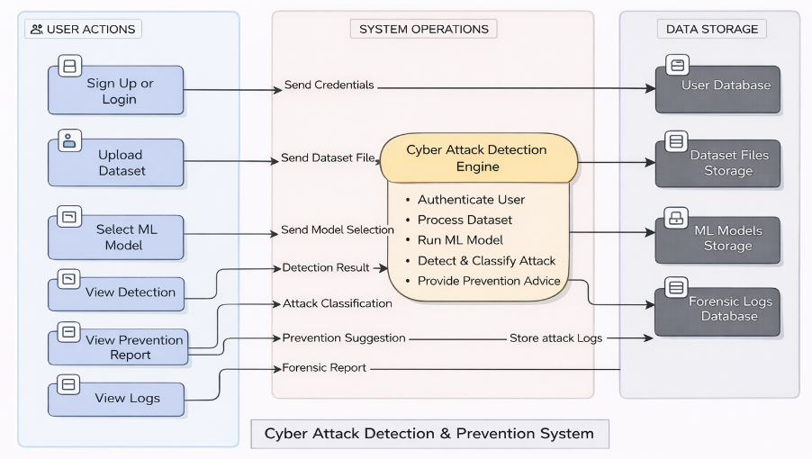
Fig 3.3: System Modules of the proposed system

Need for Unified Ensemble Model
In traditional cyberattack detection systems, a single machine learning model is used, which limits the ability to detect and classify different types of attacks accurately. Each model performs well for specific patterns but fails to provide consistent results in dynamic network conditions. Wireless Sensor Networks require a more reliable approach due to varying traffic and evolving attack patterns.
To overcome these limitations, the proposed system uses a unified ensemble learning approach that combines multiple models such as Random Forest, XGBoost, Multilayer Perceptron, and Autoencoder. This integration improves detection accuracy, enhances stability, and enables the system to identify both known and unknown cyberattacks effectively.

Dataset Processing Workflow

Training Dataset
The dataset used to train the proposed model is the WSN-DS dataset, which consists of 374,661 samples of network communication including both normal traffic and cyberattacks. The dataset contains various types of attacks such as Blackhole, Grayhole, Flooding, and TDMA attacks. Important network parameters used for training include packet transmission rate, routing path information, and energy consumption of nodes.
The dataset captures key network communication properties such as routing behavior, packet transmission patterns, cluster head associations, communication distance, and node power usage. These parameters play a significant role in identifying abnormal node behavior and detecting cyberattacks.
The system should perform secure key exchange using ECC between the sender and receiver.
To evaluate the model effectively, the dataset is divided into training and testing subsets. The unified ensemble model integrates Random Forest, XGBoost, Multilayer Perceptron (MLP), and Autoencoder within a single framework, which improves detection accuracy, enhances classification stability, and enables anomaly detection in Wireless Sensor Networks.

Simulation Environment
To validate the performance of the proposed unified ensemble model under realistic conditions, additional network traffic is generated using the COOJA network simulator, which is part of the Contiki-NG operating system. COOJA is a realistic simulation environment that mimics sensor node hardware behavior, wireless communication protocols, and radio transmission characteristics.
The simulator models various aspects of network behavior, including packet transmission, node energy consumption, and network topology. It supports both normal network communication and malicious node behavior, making it suitable for testing cyberattack detection systems in real-world WSNs scenarios.
In the simulation setup, sensor nodes are randomly deployed within a defined area, and a base station is placed centrally to collect data. The nodes communicate using multi-hop routing, where data is transmitted through intermediate nodes to ensure reliable communication. The network follows IEEE 802.15.4 communication standards, commonly used in WSN and IoT applications.
Initially, the simulation runs under normal conditions to establish baseline network behavior, including packet transmission rate, routing patterns, communication delay, and energy consumption. After establishing normal behavior, cyberattack scenarios are introduced by modifying the behavior of selected nodes. This helps in analyzing how attacks affect network performance and communication stability.
The simulation generates network communication logs at the mote output level, which include details of the network. These logs are processed using scripts and converted into CSV format for further analysis. The processed simulation data is then used to test and validate the performance of the proposed system.
Settings | Values Used In Simulation
Node Type | Cooja sensor mote
Number Of Nodes | 200 nodes
Node Distribution | Random deployment in 200m x 200m area
Simulation Time | 900 seconds
Radio Medium | UDGM (Unit Disk Graph Medium)
Transmission Range | 50 meters
MAC Protocol | IEEE 802.15.4
Communication Protocol | UDP
Packet Transmission Interval | 5 seconds
Energy Consumption Monitoring | Enabled (per-node energy tracking)
Network Traffic Logs | Mote output logs converted to CSV format

Table 3.5.2 : COOJA Simulation Settings

Methodology
The proposed methodology is based on a unified ensemble learning approach for detecting and classifying cyberattacks in Wireless Sensor Networks. Instead of relying on a single model, the system integrates multiple machine learning and deep learning models to analyze different patterns of network traffic and improve overall detection performance.
The methodology uses Random Forest, XGBoost, and Multilayer Perceptron (MLP) as supervised learning models for classifying known cyberattacks. Random Forest is selected due to its ability to handle noisy and high-dimensional data, which is common in Wireless Sensor Network traffic. It provides stable and reliable classification results by constructing multiple decision trees and combining their outputs.
Multilayer Perceptron (MLP), a deep learning model, is used to learn nonlinear relationships present in network traffic data. Wireless Sensor Network communication often involves complex interactions between parameters such as packet transmission rate, routing behavior, and energy consumption. MLP captures these nonlinear patterns and improves the system’s ability to classify different attack types.
Autoencoder is used for anomaly detection in the proposed system. It is trained using normal network traffic and learns the standard behavior of the network. When abnormal or unseen data is encountered, the model detects deviations based on reconstruction error, allowing the system to identify unknown or emerging cyberattacks that are not present in the training dataset.
The outputs of the supervised models (Random Forest, XGBoost, and MLP) are combined using stacking ensemble learning. In this approach, the predictions of individual models are used as input to a final classifier, which produces the final classification result. This method improves detection accuracy, reduces false positives and false negatives, and enhances classification stability.

Algorithm: Unified Ensemble Framework for Cyberattack Detection
The proposed algorithm describes the step-by-step process of detecting and classifying cyberattacks in Wireless Sensor Networks using a unified ensemble learning approach. It integrates multiple machine learning and deep learning models along with anomaly detection to improve accuracy and reliability.
- Dataset Preparation:
Split processed dataset $D_{proc}$ into training and testing sets:
$$\{D_{train},D_{test}\} = Split(D_{proc})$$
- Model Initialization:
Base classifiers: Random Forest, XG Boost (XGB), Multilayer Perceptron (MLP) and Autoencoder (AE) is used for anomaly detection.
- Model Training:
Train RF, XGB, and MLP using $D_{train}$
Train AE using only normal traffic samples $D_{normaltrain}$​.
- Meta-Feature Generation:
Generate base model outputs
$${{MF}_{train}}_{}= \left\{ RF\left(x\right),XGB\left(x\right),MLP\left(x\right)\right\},∀x∈D_{train}​.$$
- Meta-Learner Training:
Train stacking classifier using ${MF}_{train}$and labels $Y_{train}$
- Prediction:
Generate meta-features MF(x)MF(x)MF(x) and obtain final classification
$$C(x)=Meta(MF(x))$$
- Anomaly Detection:
The Autoencoder computes the reconstruction error:
$${{RE(x)=∣∣x-AE(x)∣∣}^{2}}_{}$$
- Threshold Calculation:
The anomaly threshold is calculated using training reconstruction error statistics
$$τ=μ(REtrain​)+kσ(REtrain​)$$
- Unknown Attack Detection:
If $RE(x)> τ$, the input is classified as an unknown attack; otherwise, it is treated as normal or classified using the ensemble model.
- Final Decision:
If an anomaly is detected, the output is Unknown Attack; otherwise, the ensemble classifier output $C(x)$ is returned.

  - Attack Detection Mechanism
The attack detection mechanism in the proposed system is designed to identify, classify, and analyze cyberattacks in Wireless Sensor Networks using both supervised and unsupervised learning techniques. The system processes network traffic data and detects abnormal patterns based on trained models.
Initially, the data is analyzed using machine learning models such as Random Forest, XGBoost, and Multilayer Perceptron, which classify the traffic into normal or specific attack categories such as Blackhole, Grayhole, Flooding, and TDMA attacks. These models are combined using stacking ensemble learning to improve detection accuracy and classification stability.
In addition to classification, the system uses an Autoencoder model for anomaly detection. The Autoencoder learns normal network behavior and identifies deviations based on reconstruction error. If the error exceeds a predefined threshold, the system classifies the input as an unknown or emerging attack.
The system also identifies malicious nodes responsible for attacks by analyzing abnormal communication patterns and network behavior. Along with detection, the system generates prevention recommendations specific to each type of attack, which helps users take appropriate security measures.
All detected attacks and malicious node information are stored in forensic logs for future analysis. The system provides filtering options that allow users to view attack statistics based on time intervals such as today, yesterday, this month, and this year. Additionally, users can export these reports in PDF or CSV format for documentation and further analysis.
The detection mechanism not only identifies cyberattacks but also facilitates continuous monitoring, detailed analysis, and preventive action, thereby enhancing the effectiveness and practical applicability of the system in real-world Wireless Sensor Network environments.

IMPLEMENTATION

System Configuration
The implementation of the proposed cyberattack detection system requires both hardware and software components to ensure efficient performance.

Hardware Configuration
The hardware configuration used for implementing the system is listed below:
- Processor: Intel Core i5 or equivalent
- RAM: Minimum 8 GB
- Storage: 256 GB Hard Disk / SSD
- System Type: 64-bit operating system
- Network: Standard internet connectivity

Software Configuration
The software tools used for developing and implementing the system include the following:
- Operating System: Windows / Linux
- Programming Language: Python, C
- Development Tool: Jupyter Notebook / VS Code
- Database: MySQL / SQLite
- Libraries: NumPy, Pandas, Scikit-learn, TensorFlow / Keras
- Simulation Tool: COOJA Simulator
- Dataset: WSN-DS Dataset

Tools and Technologies Used
The system is implemented using Python due to its extensive support for machine learning and data analysis. Libraries such as NumPy and Pandas are used for data preprocessing, while Scikit-learn is used for implementing machine learning models like Random Forest and XGBoost. TensorFlow or Keras is used for implementing deep learning models such as Multilayer Perceptron and Autoencoder.
The COOJA simulator is used to generate realistic Wireless Sensor Network traffic, including both normal and malicious scenarios. Jupyter Notebook or Visual Studio Code is used as the development environment for implementing and testing the system.

Dataset Implementation
The implementation uses two datasets: the WSN-DS dataset for training and the data generated from the COOJA simulator for testing and validation. The dataset is loaded into the system using Python libraries such as Pandas.
Preprocessing steps such as data cleaning, normalization, encoding, and feature selection are applied to improve data quality. The dataset is then split into training and testing sets to evaluate model performance. The training dataset is used to train the models, while the testing dataset is used to validate the system under realistic conditions.

Model Implementation
The proposed system implements multiple machine learning and deep learning models for cyberattack detection. Random Forest is implemented using the Scikit-learn library and is used for handling noisy data and providing stable classification results. XGBoost is implemented using the XGBoost library and is used to improve prediction accuracy by capturing complex patterns in network traffic.
The Multilayer Perceptron (MLP) model is implemented using TensorFlow or Keras to learn nonlinear relationships in the data. The Autoencoder model is also implemented using deep learning frameworks and is trained only on normal network traffic to detect anomalies based on reconstruction error.
Each model is trained individually using the training dataset, and their outputs are later combined using stacking ensemble learning to improve overall detection performance.

System Workflow Implementation
The system workflow is implemented using Python to handle data processing, model execution, attack detection, and result management. Initially, the dataset is loaded using the Pandas library and preprocessed using functions for data cleaning, normalization, encoding, and feature selection.
The trained machine learning models such as Random Forest, XGBoost, and Multilayer Perceptron are loaded and used to generate predictions for input network traffic data. The outputs from these models are combined using a stacking ensemble method implemented through a meta-classifier to produce the final classification result. The Autoencoder model is used to compute reconstruction error, and a threshold value is applied to identify anomalies.
For malicious node detection, the system analyzes network parameters such as node ID, packet transmission behavior, routing patterns, and abnormal communication frequency. Nodes showing abnormal behavior or participating in attack patterns are flagged as malicious and stored in the system.
Prevention recommendations are implemented using predefined rule-based mappings, where each detected attack type is associated with specific prevention strategies. Based on the classification output, the system retrieves and displays the corresponding prevention measures.
All detected attacks and malicious node details are stored in a structured database (such as SQLite or JSON-based storage). Each record includes attributes such as attack type, node ID, timestamp, and severity level.
To support filtering functionality, queries are implemented to retrieve attack logs based on time intervals such as current day, previous day, monthly, and yearly data. This is achieved using timestamp-based filtering logic.
For report generation, the system uses Python libraries such as Pandas and ReportLab (or CSV writer) to export the filtered data into PDF and CSV formats. The exported reports include attack details, malicious nodes, and statistical summaries.

TESTING

Testing Approach
In this project, testing is carried out to verify the correctness and reliability of the proposed cyberattack detection system. Two types of testing are performed, namely functional testing and performance testing. Functional testing ensures that all modules such as data preprocessing, model execution, anomaly detection, malicious node detection, and report generation are working correctly. Performance testing evaluates the efficiency of the system in detecting cyberattacks and generating outputs within acceptable time.

Features to be Tested
After implementing the complete system, the following features are tested to ensure proper functionality:
- Verify that the system correctly loads and preprocesses the dataset.
- Ensure that machine learning models correctly classify network traffic into normal and attack categories.
- Check whether ensemble learning improves classification performance.
- Verify that the Autoencoder detects unknown attacks effectively.
- Ensure that malicious nodes are correctly identified.
- Check whether attack logs and reports are generated correctly.

Testing tools and environment
- Programming Environment: Visual Studio Code / Jupyter Notebook – used to develop and test the cyberattack detection system.
- Programming Language: Python – used to implement data preprocessing, machine learning models, and anomaly detection.
- Libraries: NumPy, Pandas, Scikit-learn, TensorFlow/Keras – used for data handling, model training, and evaluation.
- Database: MySQL / SQLite - it stores user credentials, store attack logs, malicious node information, and generated reports.
- Dataset: WSN-DS Dataset – used for training and evaluating the detection models.
- Simulation Tool: COOJA Simulator – used to generate realistic Wireless Sensor Network traffic for testing.

Test cases

Input
This project requires the following inputs:
- User authentication credentials: Username and password are required for user authentication to securely access the system.
- Dataset input: The user uploads the dataset to analyze network traffic and detect cyberattacks.

Expected Output
The following outcomes are expected from the proposed system:
- Successful authentication of users using valid credentials.
- Accurate classification of network traffic into normal and different attack types.
- Detection of cyberattacks such as Blackhole, Grayhole, Flooding, and TDMA attacks.
- Identification of malicious nodes involved in the attacks.
- Detection of unknown or new attacks using anomaly detection.
- Generation of prevention recommendations based on detected attacks.
- Storage of attack details and malicious node information in forensic logs.
- Correct filtering of attack data based on time intervals such as today, yesterday, monthly, and yearly.
- Successful export of reports in PDF and CSV formats.

Testing Procedure
The following procedure is used to test the proposed system:
  - Successful login of the user with access to system modules such as Upload, Algorithm, Dashboard, Forensics, and View Data.
  - In the Upload section, the system accepts the dataset and performs cyberattack detection, providing prediction results.
  - The uploaded dataset is displayed in the View Data section for user verification and analysis.
  - The Dashboard displays dataset analytics, attack statistics, and identified malicious nodes
  - The Algorithm section shows performance metrics of the unified ensemble model, including accuracy, classification results, and confusion matrix.
  - The Forensics section stores attack logs, including detected attacks and malicious node information for future analysis.

PERFORMANCE METRICS
The performance of the proposed Unified Ensemble Learning based Cyberattack Detection System is evaluated using standard performance metrics. These metrics help in analyzing how effectively the system detects and classifies cyberattacks in WSNs.
The evaluation is carried out using the testing dataset, and the results are measured based on metrics such as Accuracy, Precision, Recall, F1-Score, Confusion Matrix, and ROC Curve. These metrics provide a clear understanding of the model’s performance in distinguishing between normal network traffic and different types of cyberattacks.

Accuracy
Accuracy is used to measure the overall correctness of the system. It indicates the percentage of correctly classified instances out of the total number of instances.
Accuracy is calculated using the following formula:
$$\frac{(TP + TN)}{(TP + TN + FP + FN)}$$
Where TP represents correctly detected attack instances, TN represents correctly detected normal instances, FP represents normal traffic that is wrongly classified as an attack, and FN represents attack instances that are wrongly classified as normal.
The proposed unified ensemble model achieves an accuracy of 99.88%, which shows that the system performs highly effectively in detecting cyberattacks.

Precision
Precision measures how accurately the system predicts attack instances among all predicted attack cases.
Precision is calculated using the following formula:
$$\frac{TP}{(TP + FP)}$$
A high precision value indicates that the system produces fewer false alarms. The proposed model achieves a precision value of approximately 0.99, indicating high reliability in prediction.

Recall
Recall, also known as detection rate, measures the ability of the system to correctly identify actual attack instances.
Recall is calculated using the following formula:
$$\frac{TP}{(TP + FN)}$$
The proposed system achieves a recall value of 0.99, which shows that it can effectively detect most of the cyberattacks present in the network.

F1-Score
F1-Score is used to measure the balance between precision and recall. It is the harmonic mean of precision and recall.
F1-Score is calculated using the following formula:
$$2 × \frac{\left(Precision × Recall\right)}{\left(Precision + Recall\right)}$$
The proposed model achieves an F1-Score of approximately 0.99, which indicates a balanced and consistent performance.

Confusion Matrix
The confusion matrix is used to evaluate the classification performance by comparing actual and predicted values. It shows correct classifications and misclassification cases. Most values lie along the diagonal, indicating that the model correctly classifies the majority of instances, which proves its effectiveness.
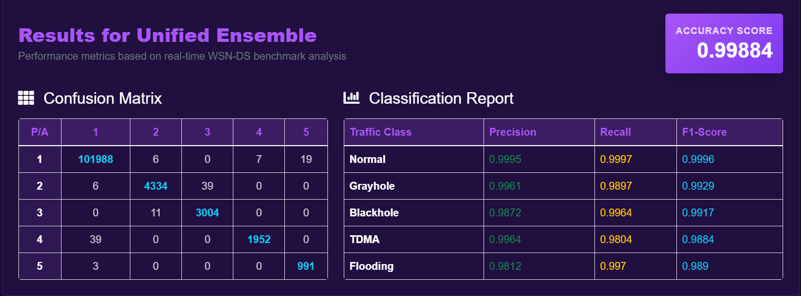

Fig. 6.5 : Confusion Matrix and Classification Report of Proposed System

ROC Curve
The ROC curve is used to evaluate the model’s ability to distinguish between normal and attack classes. The AUC represents the overall performance of the model, where an AUC value close to 1 indicates excellent performance and an AUC value close to 0.5 indicates poor performance.
The proposed unified ensemble model achieves an AUC value of 0.98, which is higher than individual models, showing better classification performance.
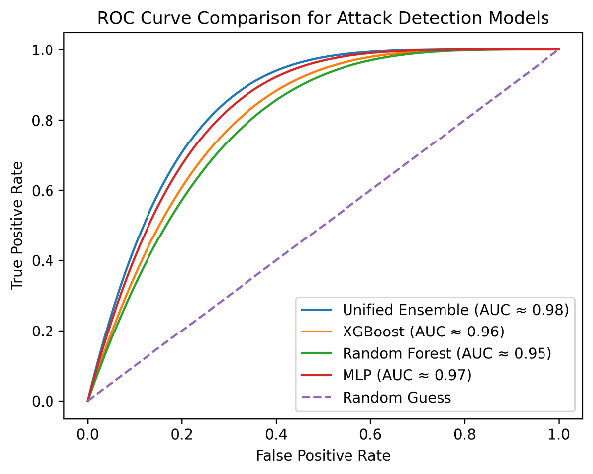

Comparative Analysis
The performance of the proposed unified ensemble model is compared with individual machine learning models.
Model | Accuracy (%) | Precision | Recall | F1- Score
Unified Ensemble | 99.88 | 0.99 | 0.99 | 0.99
XG Boost | 99.73 | 0.95 | 0.99 | 0.97
Random Forest | 99.71 | 0.93 | 0.99 | 0.96
Multilayer Perceptron | 90.76 | 0.18 | 0.20 | 0.19
Autoencoder | 99.12 | 0.98 | 0.99 | 0.98

Table 6.7 : Performance Comparison of Proposed Unified Ensemble Model with Individual Models

From the above table, it is observed that the proposed unified ensemble model achieves the highest accuracy, precision, recall, and F1-score compared to individual machine learning models. This demonstrates that combining multiple models using ensemble learning improves overall detection performance, classification stability, and reliability in identifying cyberattacks in Wireless Sensor Networks.

RESULTS
The proposed Unified Ensemble Learning based cyberattack detection system was successfully implemented and tested using the WSN-DS dataset and network traffic generated from the COOJA simulation environment. The system is designed to detect and classify different types of cyberattacks in Wireless Sensor Networks and provide real-time analysis.
The system allows users to upload network datasets and perform cyberattack detection through the user interface. After processing the data, the system classifies the network traffic into normal and different attack types such as Blackhole, Grayhole, Flooding, and TDMA attacks. The results are displayed to the user along with prediction outputs and analysis.
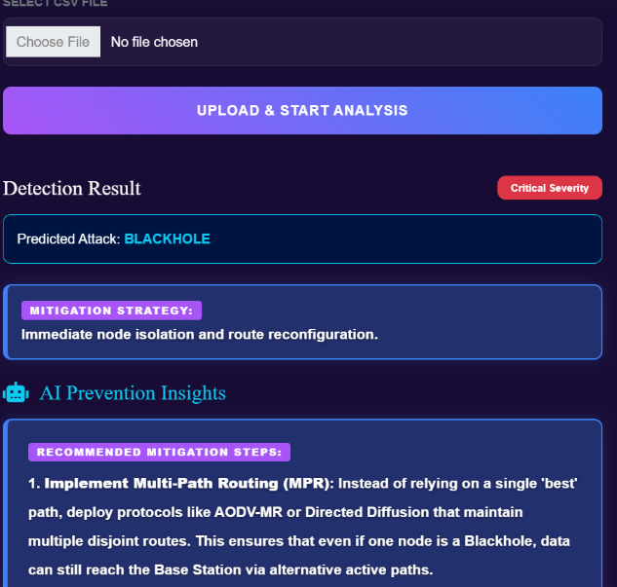
Fig 7.1: Cyberattack Detection Output Showing Predicted Attack and Mitigation Strategies

The system provides a manual input interface that allows users to enter network parameters such as node ID, communication details, energy levels, and routing information. The entered data is processed by the proposed unified ensemble model to detect potential cyberattacks. This functionality enables flexible testing and supports real-time analysis of different network scenarios.
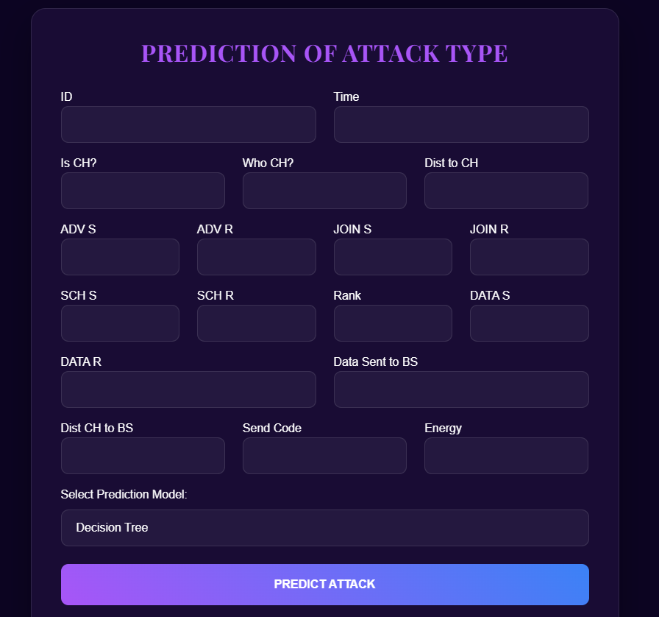
Fig 7.2: Manual Input Interface for Cyberattack Prediction
The uploaded dataset is displayed in the view data section, allowing users to examine the network traffic data in detail. It includes various parameters such as node ID, communication attributes, transmission values, and routing information. This helps in verifying the input data and understanding the features used for cyberattack detection.
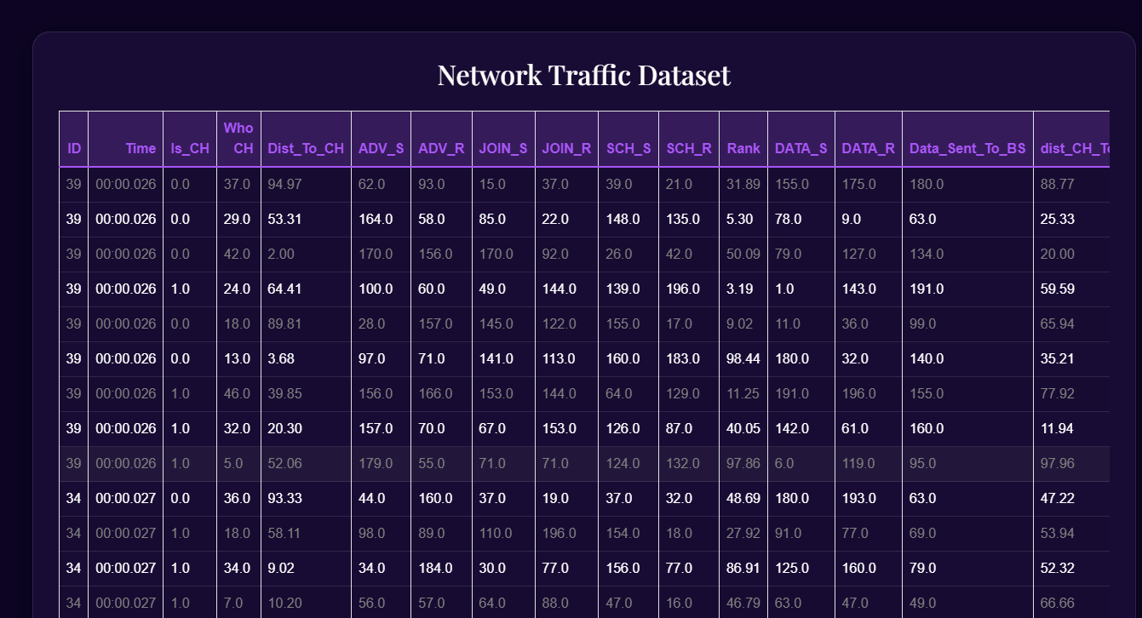
Fig 7.3: View Data Section Displaying Uploaded Network Traffic Dataset

The dashboard provides a clear visualization of dataset analytics, attack statistics, and malicious node identification. It helps users to understand the distribution of attacks and analyze network behavior effectively. The system also identifies malicious nodes based on abnormal communication patterns and network parameters.
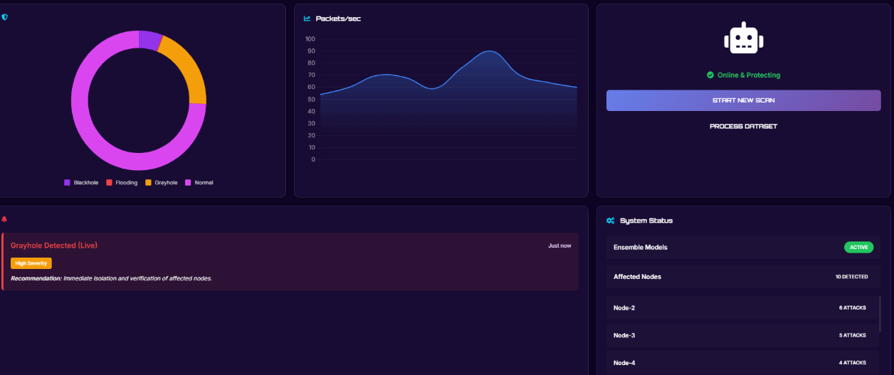
Fig 7.4: System Dashboard Displaying Attack Detection and Network Analytics
The system also includes a forensics module, where all detected attacks and malicious node details are stored as logs. These logs can be filtered based on time intervals such as daily, monthly, and yearly data. This helps in analyzing past attacks and improving network security.


Fig 7.5: Forensic Module Showing Attack Logs and Mitigation Details

The system visualizes attack frequency trends and node risk distribution to provide better insights into network behavior. The attack frequency graph shows the variation of detected attacks over time, helping to identify patterns and peak attack periods. The node risk summary represents the distribution of risk levels such as critical, high, medium, and low across the network. This helps in understanding the severity of attacks and prioritizing security measures effectively.
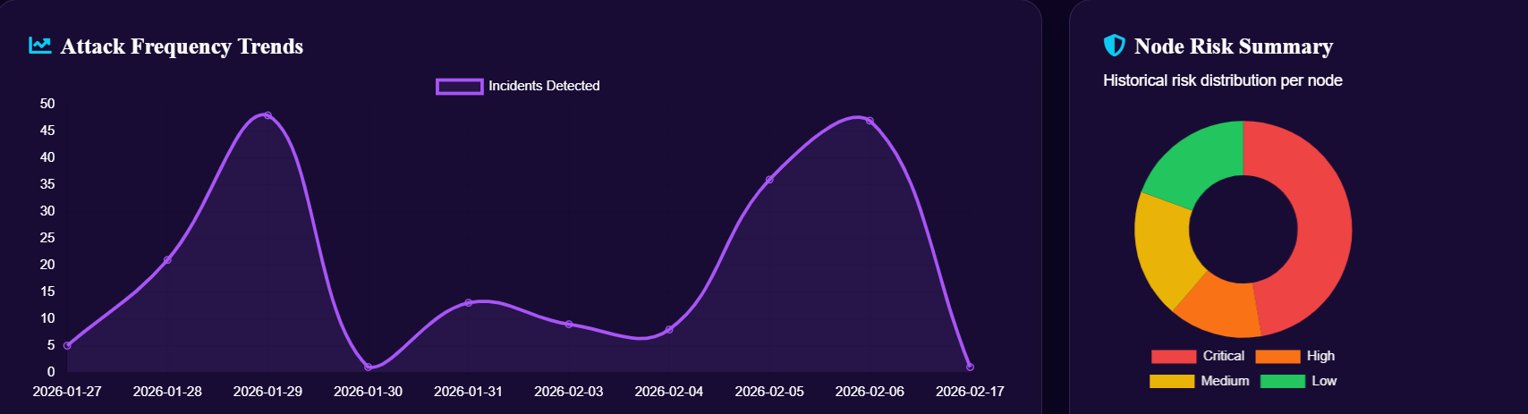

Fig 7.6: Attack Frequency Trends and Node Risk Distribution

The forensic attack logs can be exported as a PDF report for easy documentation. The report includes important details such as timestamp, attack type, node ID, severity, and mitigation actions. This helps in keeping proper records of attacks and makes it easier to analyze and review security incidents.
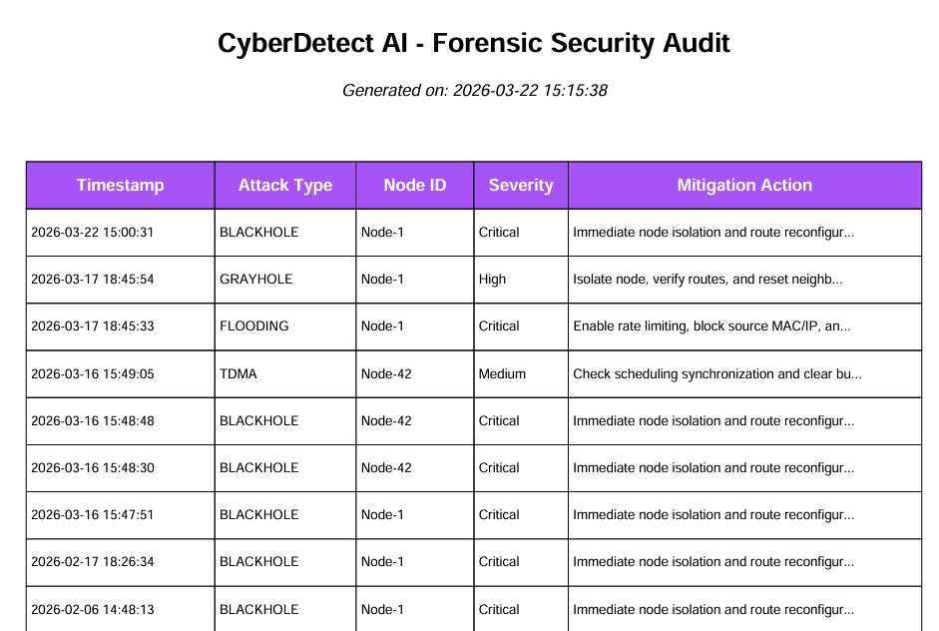

Fig 7.7: Generated PDF Report of Forensic Attack Logs
The attack logs can also be exported in CSV format for easy data handling and analysis. The CSV file contains details such as attack type, node ID, segment, severity, and mitigation information. This allows users to view, edit, and analyze the data using tools like Excel, making it useful for further study and record keeping.
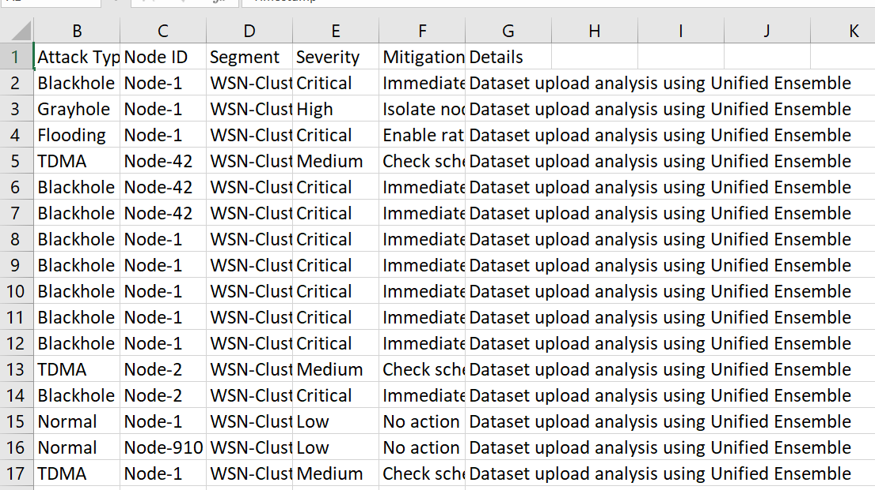
Fig 7.8: CSV Report of Cyberattack Detection Logs
An AI chatbot is integrated into the system to provide quick information about the project and assist users. It can explain project details, features, and functionality in an interactive manner. This improves user experience and helps users understand the system more easily.


Fig 7.9: AI Chatbot for User Assistance

CONCLUSION
In conclusion, the proposed unified ensemble learning based cyberattack detection system for Wireless Sensor Networks has been successfully designed and implemented. The system effectively detects and classifies different types of cyberattacks such as Blackhole, Grayhole, Flooding, and TDMA attacks using a combination of machine learning and deep learning models.
The integration of multiple models in the form of a unified ensemble improves detection accuracy, classification stability, and overall system reliability. The system also supports anomaly detection to identify unknown or emerging attacks, making it more robust in dynamic network environments.
The implementation includes features such as real-time attack detection, dashboard visualization, forensic logging, PDF and CSV report generation, and an AI chatbot for user assistance. These features enhance the usability and practical applicability of the system.
The results demonstrate that the proposed system achieves high accuracy and provides efficient cyberattack detection with reliable performance. Overall, the system can be effectively used in real-world Wireless Sensor Network environments to improve network security and prevent cyber threats.
In future, the system can be extended to support large-scale and real-time network environments. It can be integrated with security systems such as firewalls and monitoring tools for better protection. Further improvements can focus on making the model more adaptive to evolving cyberattack patterns.

REFERENCES
- Dr. B. Karthikeyan, MS. M. Kamali , " Detection of Attacks in Wireless Sensor Networks Using Machine Learning Algorithms " , International Journal of Research Publication and Reviews, Vol 6, no 2, pp 3454-3460 February 2025
- Al-Quayed, Z. Ahmad, and M. Humayun, "A Situation Based Predictive Approach for Cybersecurity Intrusion Detection and Prevention Using Machine Learning and Deep Learning Algorithms in Wireless Sensor Networks of Industry 4.0," IEEE Access, vol. 12, pp. 34800-34816, 2024, presented at the IEEE Access Conference,New York, USA, March 2024, doi: 10.1109/ACCESS.2024.3372187
- M. Anwer, S. M. Khan, M. U. Farooq, and . Waseemullah, “Attack Detection in IoT using Machine Learning”, Eng. Technol. Appl. Sci. Res., vol. 11, no. 3, pp. 7273–7278, Jun. 2021
- Delwar, Tahesin Samira, Unal Aras, Sayak Mukhopadhyay, Akshay Kumar, Ujwala Kshirsagar, Yangwon Lee, Mangal Singh, and Jee-Youl Ryu. 2024. "The Intersection of Machine Learning and Wireless Sensor Network Security for Cyber-Attack Detection: A Detailed Analysis" Sensors 24, no. 19: 6377. https://doi.org/10.3390/s24196377
- Tamara Zhukabayeva, Atdhe Buja, Melinda Pacolli, Yerik Mardenov, "Detecting network security incidents in wireless sensor networks using machine learning ," Detecting network security incidents in wireless sensor networks using machine learning Indonesian Journal of Electrical Engineering and Computer Science,Vol. 37, No. 3, March 2025, pp. 1650~1660, ISSN: 2502-4752, DOI: 10.11591/ijeecs.v37.i3.pp1650-1660,DOI: http://doi.org/10.11591/ijeecs.v37.i3.pp1650-1660
- Behiry, M.H., Aly, M. Cyberattack detection in wireless sensor networks using a hybrid feature reduction technique with AI and machine learning methods. J Big Data 11, 16 (2024). https://doi.org/10.1186/s40537-023-00870-w
- G. Al Sukkar and S. Al-Sharaeh, “Enhancing Security in Wireless Sensor Networks: A Machine Learning-based DoS Attack Detection”, Eng. Technol. Appl. Sci. Res., vol. 15, no. 1, pp. 19712–19719, Feb. 2025.
- Khan, I., Junaid Khan, Bangash, S. H., Waqas Ahmad, Khan, A. I., & hameed , khalid. (2024). Intrusion Detection Using Machine Learning and Deep Learning Models on Cyber Security Attacks. VFAST Transactions on Software Engineering, 12(2), 95–113. https://doi.org/10.21015/vtse.v12i2.1817.
- Sadia, H., “Intrusion Detection System for Wireless Sensor Networks: A Machine Learning Based Approach”, IEEE Access, vol. 12, IEEE, pp. 52565–52582, 2024. doi:10.1109/ACCESS.2024.3380014
- Buja, Atdhe & Zhukabayeva, Tamara & Pacolli, Melinda & Mardenov, Yerik. (2025). Detecting network security incidents in wireless sensor networks using machine learning. Indonesian Journal of Electrical Engineering and Computer Science. 37. 1650-1660. 10.11591/ijeecs.v37.i3.pp1650-1660.
- A. N. Doss, D. Shah, G. F. Smaisim, M. Olha and S. Jaiswal, "A Comprehensive Analysis of Internet of Things (IOT) in Enhancing Data Security for Better System Integrity - A Critical Analysis on the Security Attacks and Relevant Countermeasures," 2022 2nd International Conference on Advance Computing and Innovative Technologies in Engineering (ICACITE), Greater Noida, India, 2022, pp. 165-167, doi: 10.1109/ICACITE53722.2022.9823817.
- K. J. Gnanaselvi, S. K. Shukla, K. Kumar, A. Gehlot, T. Jaiswal and B. T. Geetha, "A Novel based Hybrid smart System for detecting the cyber-attacks on IOT’s," 2023 International Conference on Artificial Intelligence and Smart Communication (AISC), Greater Noida, India, 2023, pp. 600-604, doi: 10.1109/AISC56616.2023.10085521.
- S. L. Bangare, S. Prakash, K. Gulati, B. Veeru, G. Dhiman and S. Jaiswal, "The Architecture, Classification, and Unsolved Research Issues of Big Data extraction as well as decomposing the Internet of Vehicles (IoV)," 2021 6th International Conference on Signal Processing, Computing and Control (ISPCC), Solan, India, 2021, pp. 566-571, doi: 10.1109/ISPCC53510.2021.9609451.
- Ismail, S.; El Mrabet, Z.; Reza, H. An Ensemble-Based Machine Learning Approach for Cyber-Attacks Detection in Wireless Sensor Networks. Appl. Sci. 2023, 13, 30. https://doi.org/10.3390/app13010030

